PRACTICAL ASSIGNMENT - 5

* Name: Hardik Arora
* Branch : Btech - CS
* Program: AIML
* University Roll No. : 2215500071
* Section: 2AC
* Class Roll No. : 28

CREATE DATABASE p4;

USE p4;

CREATE TABLE IF NOT EXISTS Student (

    sID INT PRIMARY KEY,

    sName VARCHAR(50),

    GPA FLOAT,

    sizeHS INT NOT NULL

);

INSERT INTO student(sID, sName, GPA, sizeHS) VALUES ('123', 'Amy', '3.9', '1000');

INSERT INTO student(sID, sName, GPA, sizeHS) VALUES ('234', 'Bob', '3.6', '1500');

INSERT INTO student(sID, sName, GPA, sizeHS) VALUES ('345', 'Craig', '3.5', '500');

INSERT INTO student(sID, sName, GPA, sizeHS) VALUES ('456', 'Doris', '3.9', '1000');

INSERT INTO student(sID, sName, GPA, sizeHS) VALUES ('567', 'Edward', '2.9', '2000');

INSERT INTO student(sID, sName, GPA, sizeHS) VALUES ('678', 'Fay', '3.8', '200');

INSERT INTO student(sID, sName, GPA, sizeHS) VALUES ('789', 'Gary', '3.4', '800');

INSERT INTO student(sID, sName, GPA, sizeHS) VALUES ('987', 'Helen', '3.7', '800');

INSERT INTO student(sID, sName, GPA, sizeHS) VALUES ('876', 'Irene', '3.9', '400');

INSERT INTO student(sID, sName, GPA, sizeHS) VALUES ('765', 'Jay', '2.9', '1500');

INSERT INTO student (sID, sName, GPA, sizeHS) VALUES ('654', 'Amy', '3.9', '1000');

INSERT INTO student (sID, sName, GPA, sizeHS) VALUES ('543', 'Craig', '3.4', '2000');

SELECT * FROM student;

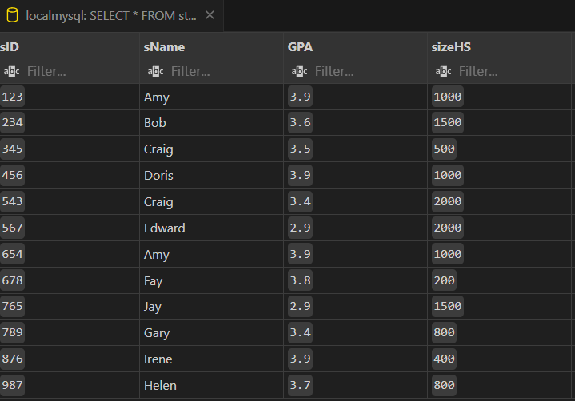

CREATE TABLE IF NOT EXISTS College(

    cName VARCHAR(50) PRIMARY KEY,

    State VARCHAR(50),

    enrollment INT NOT NULL

);

INSERT INTO college(cName, State, enrollment) VALUES('Stanford', 'CA', '15000');

INSERT INTO college(cName, State, enrollment) VALUES('Berkeley', 'CA', '36000');

INSERT INTO college(cName, State, enrollment) VALUES('MIT', 'MA', '10000');

INSERT INTO college(cName, State, enrollment) VALUES('Cornell', 'NY', '21000');

INSERT INTO college(cName, State, enrollment) VALUES('Harvard', 'MA', '50040');

SELECT * FROM college;

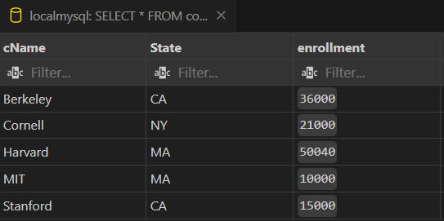

CREATE TABLE IF NOT EXISTS Applied(

    sID INT NOT NULL,

    cName VARCHAR(50) NOT NULL,

    major VARCHAR(50) NOT NULL,

    decision VARCHAR(1) NOT NULL

);

INSERT INTO Applied(sID, cName, major, decision) VALUES('123', 'Stanford', 'CS', 'Y');

INSERT INTO Applied(sID, cName, major, decision) VALUES('123', 'Stanford', 'EE', 'N');

INSERT INTO Applied(sID, cName, major, decision) VALUES('123', 'Berkeley', 'CS', 'Y');

INSERT INTO Applied(sID, cName, major, decision) VALUES('123', 'Cornell', 'EE', 'Y');

INSERT INTO Applied(sID, cName, major, decision) VALUES('234', 'Berkeley', 'biology', 'N');

INSERT INTO Applied(sID, cName, major, decision) VALUES('345', 'MIT', 'bioengineering', 'Y');

INSERT INTO Applied(sID, cName, major, decision) VALUES('345', 'Cornell', 'bioengineering', 'N');

INSERT INTO Applied(sID, cName, major, decision) VALUES('345', 'Cornell', 'CS', 'Y');

INSERT INTO Applied(sID, cName, major, decision) VALUES('345', 'Cornell', 'EE', 'N');

INSERT INTO Applied(sID, cName, major, decision) VALUES('678', 'Stanford', 'history', 'Y');

INSERT INTO Applied(sID, cName, major, decision) VALUES('987', 'Stanford', 'CS', 'Y');

INSERT INTO Applied(sID, cName, major, decision) VALUES('987', 'Berkeley', 'CS', 'Y');

INSERT INTO Applied(sID, cName, major, decision) VALUES('876', 'Stanford', 'CS', 'N');

INSERT INTO Applied(sID, cName, major, decision) VALUES('876', 'MIT', 'biology', 'Y');

INSERT INTO applied(sID, cName, major, decision) VALUES('876', 'MIT', 'marine biology', 'N');

INSERT INTO Applied(sID, cName, major, decision) VALUES('765', 'Stanford', 'history', 'Y');

INSERT INTO applied(sID, cName, major, decision) VALUES('765', 'Stanford', 'history', 'N');

INSERT INTO applied(sID, cName, major, decision) VALUES('765', 'Cornell', 'history', 'N');

INSERT INTO applied(sID, cName, major, decision) VALUES('765', 'Cornell', 'psychology', 'Y');

INSERT INTO applied(sID, cName, major, decision) VALUES('543', 'MIT', 'CS', 'N');

SELECT * FROM applied;

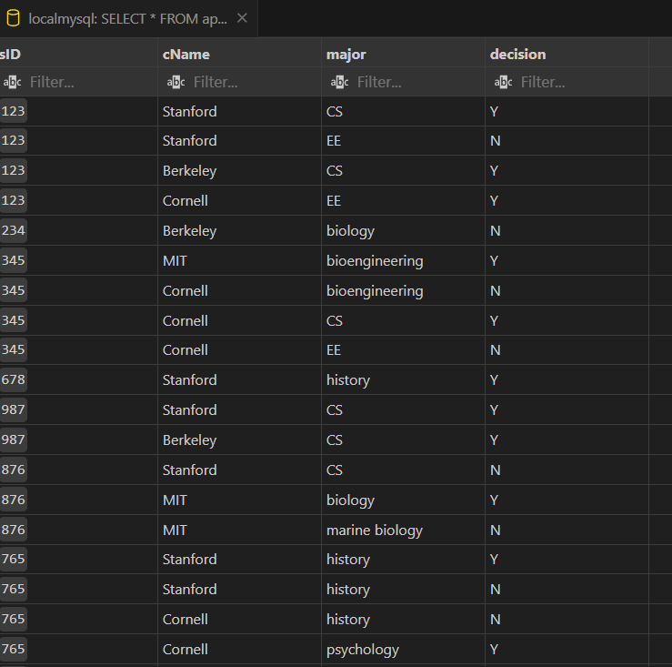

## Write SQL queries for the following:

Q1. IDs and names of students who have applied to major in CS at some college.

SELECT DISTINCT s.sID, s.sName

FROM Student s

JOIN Applied a ON s.sID = a.sID

WHERE a.major = 'CS';

Q2. Find ID and name of student having same high school size as Jay.

SELECT sID, sName

FROM Student

WHERE sizeHS = (SELECT sizeHS FROM Student WHERE sID = '765') AND sID != '765';

Q3. Find ID and name of student having same high school size as Jay but result should not include Jay.

SELECT sID, sName

FROM Student

WHERE sizeHS = (SELECT sizeHS FROM Student WHERE sID = '765') AND sID != '765';

Q4. Find the name of student with their GPA and Sid whose GPA not equal to GPA of Irene?

SELECT sID, sName, GPA

FROM Student

WHERE GPA != (SELECT GPA FROM Student WHERE sName = 'Irene');

Q5. Find college where any student having their name started from J have applied?

SELECT DISTINCT cName

FROM Applied

WHERE sID IN (SELECT sID FROM Student WHERE sName LIKE 'J%');

Q6. Find all different major where Irene has applied?

SELECT DISTINCT major

FROM Applied

WHERE sID = (SELECT sID FROM Student WHERE sName = 'Irene');

Q7. Find IDs of student and major who applied in any of major Irene had applied to?

SELECT DISTINCT a.sID, a.major

FROM Applied a

WHERE a.major IN (SELECT DISTINCT major FROM Applied WHERE sID = (SELECT sID FROM Student WHERE sName = 'Irene'));

Q8. Find IDs of student and major who applied in any of major Irene had applied to? But this time exclude Irene sID from the list.

SELECT DISTINCT a.sID, a.major

FROM Applied a

WHERE a.major IN (SELECT DISTINCT major FROM Applied WHERE sID = (SELECT sID FROM Student WHERE sName = 'Irene'))

AND a.sID != (SELECT sID FROM Student WHERE sName = 'Irene');

Q9. Give the number of colleges Jay applied to? (Remember count each college once no matter if he applied to same college twice with different major)

SELECT COUNT(DISTINCT cName) AS NumColleges

FROM Applied

WHERE sID = '765';

Q10. Find sID of student who applied to more or same number of college where Jay has applied?

SELECT sID

FROM Applied

GROUP BY sID

HAVING COUNT(DISTINCT cName) >= (SELECT COUNT(DISTINCT cName) FROM Applied WHERE sID = '765');

Q11. Find details of Students who applied to major CS but not applied to major EE? (sID 987, 876, 543 should only be include in result)

SELECT sID, sName, GPA, sizeHS

FROM Student

WHERE sID IN (

    SELECT DISTINCT a.sID

    FROM Applied a

    WHERE a.major = 'CS'

)

AND sID NOT IN (

    SELECT DISTINCT a.sID

    FROM Applied a

    WHERE a.major = 'EE'

)

AND sID IN ('987', '876', '543');

Q12. All colleges such that some other college is in same state. (Cornell should not be part of result as no other college in New York Hint: use exists)

SELECT cName, State

FROM College c1

WHERE EXISTS (

    SELECT 1

    FROM College c2

    WHERE c1.State = c2.State

    AND c1.cName != c2.cName

)

AND cName != 'Cornell';

Q13. Find the college with highest enrollment.

SELECT cName, enrollment

FROM College

WHERE enrollment = (SELECT MAX(enrollment) FROM College);

Q14. Find name of student having lowest GPA.

SELECT sName

FROM Student

WHERE GPA = (SELECT MIN(GPA) FROM Student);

Q15. Find the most popular major.

SELECT major, COUNT(*) AS popularity

FROM Applied

GROUP BY major

ORDER BY popularity DESC

LIMIT 1;

Q16. Find sID, sName, sizeHS of all students NOT from smallest HS

SELECT sID, sName, sizeHS

FROM Student

WHERE sizeHS != (SELECT MIN(sizeHS) FROM Student);

Q17. Find the name of student who applies to all the colleges where sID 987 has applied? (Hint: see Query Find IDs of student applied to all colleges)

insert into Applied

select s1.sID, 'Berkeley', 'CSE', 'Y'

from Student s1

where s1.sID IN (select s.sID from Student s

MINUS

select a.sID from Applied a where a.cName = 'Berkeley');

Q18. . Find sid of student who have not applied to Stanford.

SELECT sID

FROM Student

EXCEPT

SELECT sID

FROM Applied

WHERE cName = 'Stanford';

Q19. Find sid of Student that applied to both Stanford and Berkeley.

SELECT sID

FROM Applied

WHERE cName = 'Stanford'

INTERSECT

SELECT sID

FROM Applied

WHERE cName = 'Berkeley';

Q20. Give list of all names including all names of colleges and students.

SELECT sName AS Name

FROM Student

UNION

SELECT cName AS Name

FROM College;

Q21. Create a table ApplicationInfo having columns sID: int, sName: varchar2(10) and number_of_applications: number(2) they filed? Populate this table with appropriate data using insert command. (Remember to include details of ALL students that have applied or not applied)

-- Create the ApplicationInfo table

CREATE TABLE ApplicationInfo (

    sID INT,

    sName VARCHAR(10),

    number_of_applications INT

);

-- Populate the ApplicationInfo table with data

INSERT INTO ApplicationInfo (sID, sName, number_of_applications)

SELECT s.sID, s.sName, COUNT(a.sID) AS number_of_applications

FROM Student s

LEFT JOIN Applied a ON s.sID = a.sID

GROUP BY s.sID, s.sName;

-- Insert data for students who have not applied

INSERT INTO ApplicationInfo (sID, sName, number_of_applications)

SELECT sID, sName, 0 AS number_of_applications

FROM Student

WHERE sID NOT IN (SELECT sID FROM Applied);

Q22. Create table ApplicationData and load with ID, name of college where they applied with state of college on runtime using single query.

-- Create the ApplicationData table

CREATE TABLE ApplicationData (

    sID INT,

    cName VARCHAR(50),

    State VARCHAR(50)

);

-- Populate the ApplicationData table with data

INSERT INTO ApplicationData (sID, cName, State)

SELECT a.sID, a.cName, c.State

FROM Applied a

JOIN College c ON a.cName = c.cName;

Q23. Stanford decide not to take any student who have also applied to its rival Berkeley turn their application decision to N. (Hint: Turn decision to N only if any student applied to both Stanford and Berkeley, Update decision of only Stanford Application )

UPDATE Applied

SET decision = 'N'

WHERE cName = 'Stanford'

AND sID IN (

    SELECT sID

    FROM Applied

    WHERE cName = 'Stanford'

    INTERSECT

    SELECT sID

    FROM Applied

    WHERE cName = 'Berkeley'

);

Q24. Delete applications that are filed Colleges situated at city ‘New York’.

DELETE FROM Applied

WHERE cName IN (

    SELECT cName

    FROM College

    WHERE City = 'New York'

);

* Name: Hardik Arora
* Branch : Btech - CS
* Program: AIML
* University Roll No. : 2215500071
* Section: 2AC
* Class Roll No. : 28
* Submitted to: Ayushi Mam
* Submissipn date: 05/05/2024